## BREAKFAST @ LS

Served *All* Day

# ...



**89 Luca Changretta**

3 free range eggs scrambled on toasted deep pan focaccia topped with grilled mushrooms, lemon zest, spring onion, parmesan, crispy streaky bacon & wild rocket

**69 Brie & Avo Breakfast**

3 free range scrambled eggs on toasted sourdough topped with Brie cheese, wild rocket, balsamic cherry tomatoes & avo (add Bacon R25)

###### 67 Fruit Salad -

Fresh seasonal fruit salad, greek yogurt & crunchy baked granola

###### 89 Salmon Breakfast

Toasted rye topped with mashed avo, 3 free range scrambled eggs, smoked salmon, balsamic cherry tomatoes & spring onion

###### 95 LS Breakfast

2 eggs (fried or scrambled), back bacon, grilled mushrooms, halloumi cheese, avo & choice of toast (Turkish, Rye, Sourdough, Health or deep pan Focaccia)

###### 67 Super Bowl -

Yogurt and banana topped with chia seeds, goji berries, toasted almonds and honey

'.·'

###### 55 Avo Toast -

Choice ofTurkish I Rye I Sourdough I Health I deep pan Focaccia

1. Mashed avo, feta, balsamic cherry tomatoes & sunflower seed
2. Mashed avo, grilled mushrooms, spring onion, wild rocket & sriracha (add bacon & fried or scrambled egg 30)

**OMELETTES**

*All omelettes are* made *with* 3 *free* range eggs *topped with alfalfa sprouts* and served *with butter* and a *choice of toast: Turkish I Rye I* Sourdough *I Health I deep pan Focaccia*

###### 65 Cheddar, fresh basil &

**Al fresco tomato**

**76 Bacon, spring onion & feta**

**73 Chorizo, red pepper** &

**avo**

**65 Cheddar, mushrooms** &

**peppadews (add Avo 25)**

**65 Brie cheese & caramelized onions** -

**(add Bacon 25)**

**SALADS**

All served with a slice of toasted deep pan Focaccia

**95 Chicken & Bacon**

Seasonal lettuce mix, red onion, cherry tomatoes, grilled chicken breast strips, crispy streaky bacon & avo dressed in homemade honey mustard

**85 Caprese** -

Mozzarella fior di latte, homemade basil pesto, wild rocket, tomato & fresh basil dressed with extra virgin olive oil

,.

. ..

### ·'

.

'

#### 109

(add Halloumi 25)

###### Thai

Seasonal lettuce mix, grilled chicken breast strips mixed in sweet chilli sauce, feta, wild rocket, toasted almonds & cherry tomatoes topped with avo & fresh coriander

**79 Greek** -

Seasonal lettuce mix, olives, feta, cucumber,

cherry tomatoes & avo dressed in a homemade creamy dressing

**109 Salmon**

Seasonal lettuce mix, smoked salmon, cherry tomato, feta, spring onion & avo dressed in a homemade creamy dressing

**95**

**109 Rump**

###### Halloumi & Walnut -

Seasonal lettuce mix, grilled halloumi, grilled orange pieces, fresh mint, walnuts & cherry tomatoes dressed in homemade honey mustard. (add grilled chicken strips 35)

Seasonal lettuce mix, grilled & sliced 21 day matured rump, red onion, grilled red peppers, feta, wild rocket, cherry tomatoes & avo, drizzled with a homemade balsamic reduction sauce

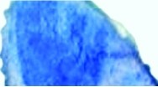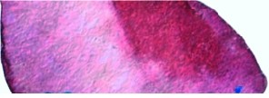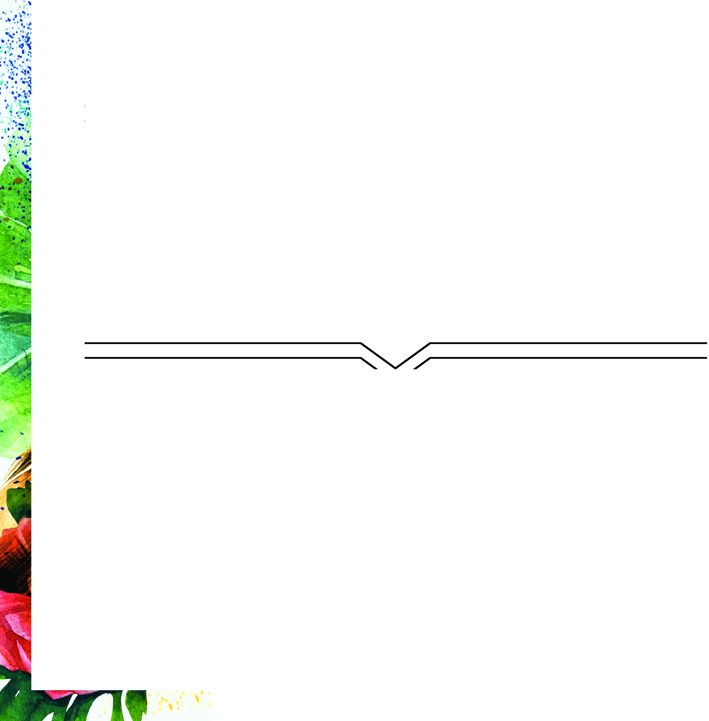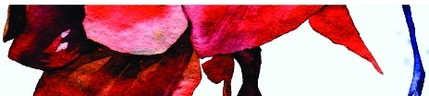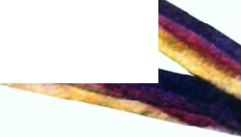

- *is for Vegetarian.*

*Wherepossible all sourced produce is organic.*

.'

## BURGERS

*All in* a *very special multi flour bun* and served *with hand cut chips Handcrafted* and *grilled per* order.



105 McLovin

Beef burger patty topped with mozzarella, homemade bacon and fig sauce & avo

**89 Bojack** -

Tomato, homemade green veg patty topped with grilled halloumi & srirracha mayo (swop veg patty for grilled chicken)

**99 Dr Gonzo**

Beef burger patty topped with brie cheese, caramelized onions, streaky bacon & smokey mayo

.

**129**

**1 25**

**99**

###### Chika Kure

Long Large beef burger patty stuffed with bacon and mozzarella, topped with cream cheese mixed L8 hot sauce and diced red onion on a Turkish Roll

###### Doctore

Large beef burger patty stuffed with bacon and gorgonzola topped with a homemade mushroom sauce and wild rocket

###### Travis Bickle

Grilled beef burger patty topped with a

#### 105

'·

. l

###### Machette

Grilled beef burger patty, mozzarella, jalapenos, cracked nachos mixed with homemade sriracha mayo and avo (swop beef burger patty for grilled chicken or veg patty)

#### 1 05

homemade mushroom sauce (swop beef burger

patty for grilled chicken or veg patty)

###### The Dude

Grilled beef burger patty topped with mozzarella, L8 hot sauce, chunky onion rings,

**99 Mr Gustave**

Grilled beef burger patty, mozzarella, grilled chorizo, caramelised onions & peri mayo

**89 The Hulk**

Grilled chicken breast topped with home made basil pesto mayo, wild rocket & avo

**119**

**95**

wild rocket and a fried egg

###### Cartman

Grilled beef burger patty topped with a homemade mushroom sauce, streaky bacon and chunky onion rings

###### Renton

Grilled chicken breast topped with L8 homemade hot sauce, feta, streaky bacon & avo

***All Burgers available bunless* & *served with a side salad instead of chips.***

## GOURMET SANDWICHES

Served *with hand cut chips (can swap for* a garden *salad]*

###### 95 Donnie Darko

Grilled chicken breasts topped with mozzarella, mango chutney mayo & crispy streaky bacon (add Avo R25)

**85 Hatchet Harry** -

Wild rocket, honey glazed beetroot, brie cheese, blanched sun dried tomatoes, homemade basil pesto & toasted almonds

**89 Lester Burnham** -

Mozzarella fior di latte, homemade basil pesto, tomato, fresh basil, wild rocket & avo, sprinkled with black sesame seeds

###### 99 Raymond Babbit

Smoked salmon, cream cheese, mixed lettuce, tomato, spring onion & avo drizzled with black sesame seeds

,.

.

..

.·'

**85 Mr Wolf**

Mixed lettuce, grilled chicken breast topped with feta, peppadews and avo, dressed in a lemon & mustard sauce (add bacon R25)

**109**

###### Bill the Butcher

Grilled and sliced 21 day matured rump on a bed of wild rocket, topped with red onion, balsamic cherry tomato, feta & drizzled with a homemade balsamic reduction sauce

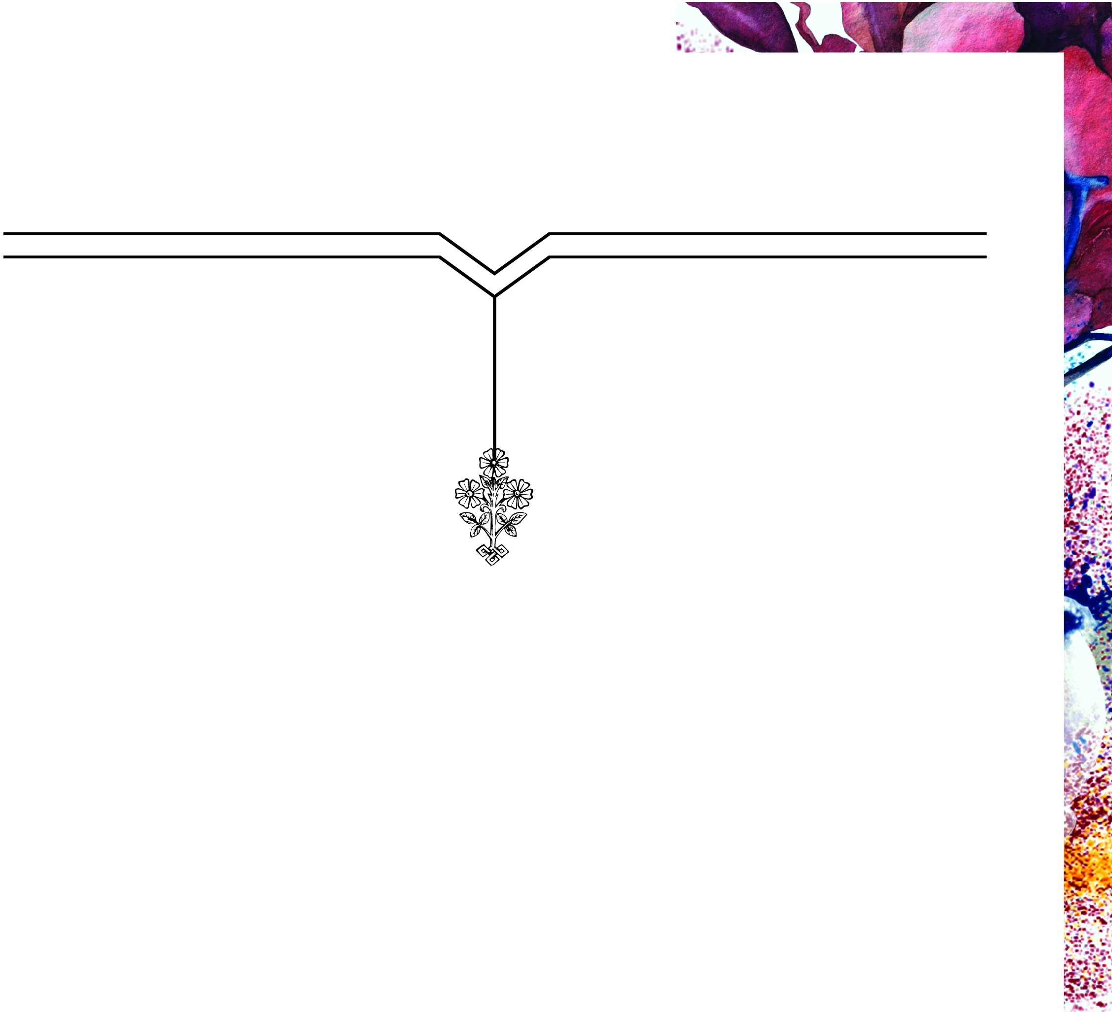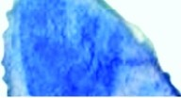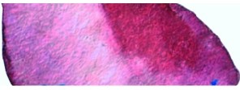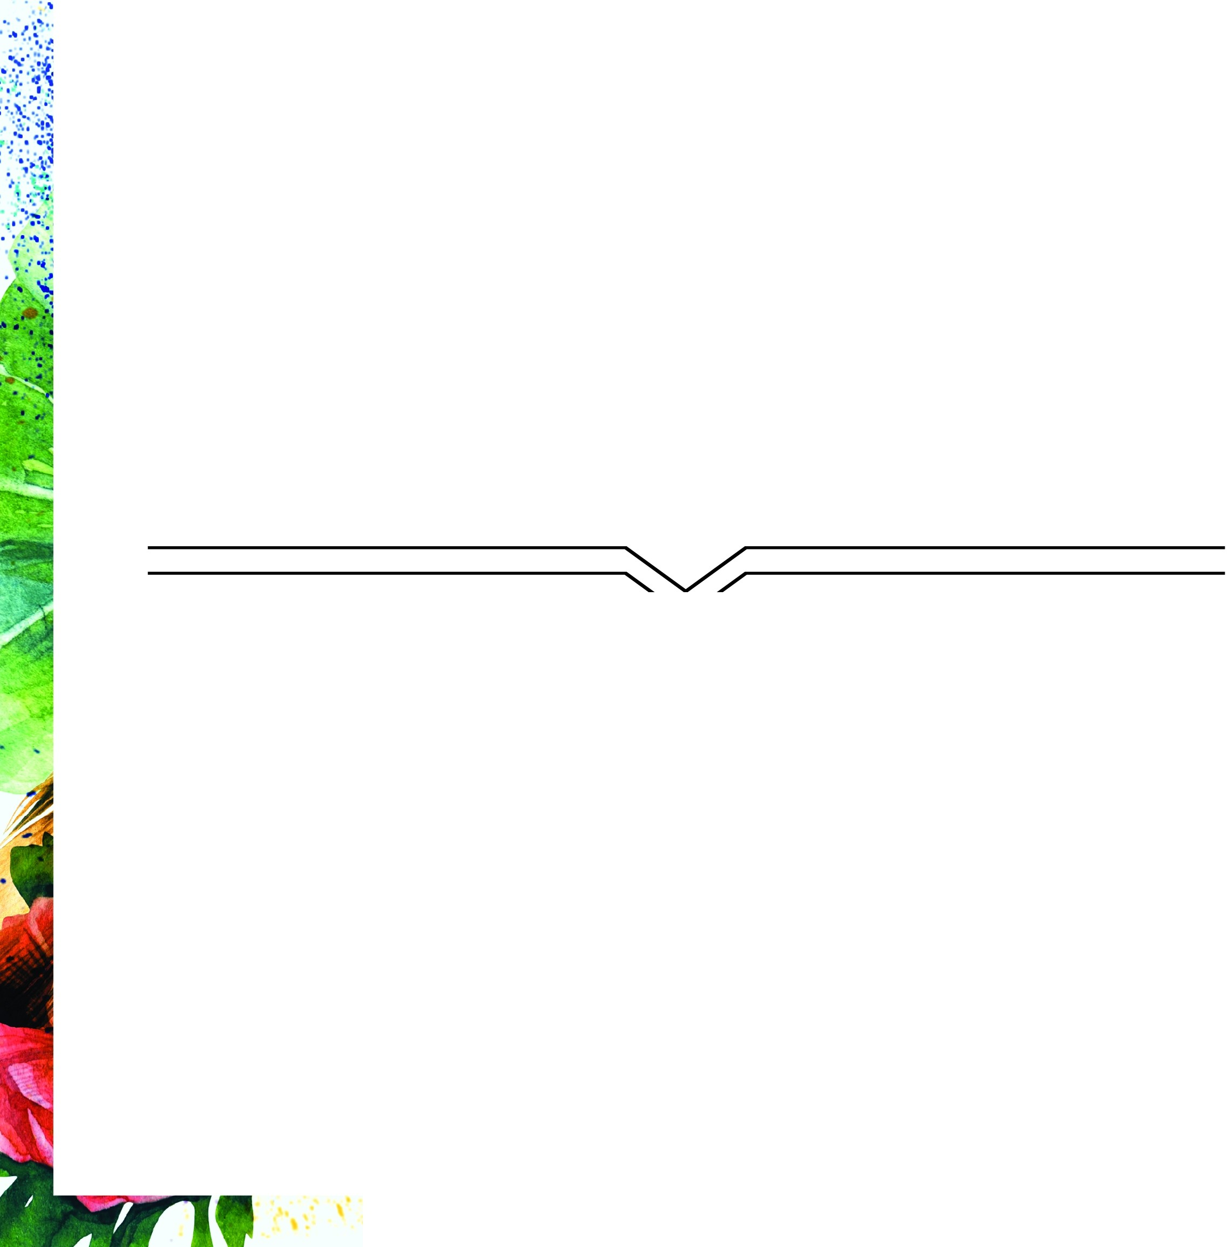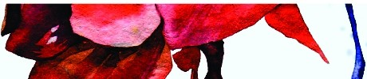

Call Us: 011 482 6985 ED Visit Our Website: [www.18cafe.com](http://www.18cafe.com/)

..

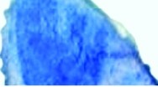 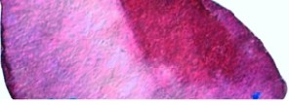

## COLD BEVERAGES

~~-~~  ~~­~~



42 Strawberry & Mint Rock Shandy



Made with freshly cut strawberries and mint, **46**

served in a tall glass **46**

**46**

39 Apple Chai Cooler 42

Apple juice infused with homemade chai and loose

leaf black african tea,served in a tall glass **25**

39 Lemonade 29

Lemon sorbet blended with wild mint

LS Milkshakes

Coffee

Red Berries Gourmet Chocolate Vanilla

Basic Sugar Laden Fizzies Appletiser *I* Grapetiser

**39 Citrus Shake**

Lemon sorbet blended with orange juice

**25** [250ml)

**80** [ l l)

Ice Tea

Kiwi, cucumber & mint

Lemongrass, coconut & ginger

...

'.·'

39 Pomegranate Shake

Lemon sorbet blended with pomegranate juice

49 44 Mango

Fresh mango,banana, honey, yogurt

and ice blended together.

**24** [350ml)

**39** [750ml)

Berry Baobab

**Mineral Water**

**HOT BEVERAGES**

1. **America no**
2. **Cappuccino**

**32 Cappuccino Large (dbl shot)**

**18 Espresso single**

**20 Espresso double**

**19 Macchiato single**

**21 Macchiato double**

**29 Mocha**

**29 Chai Latte**

**27 Cafe Latte**

29 Hot Chocolate

***26* Loose Leaf Tea Selection**

**VINO BEERS & CIDERS**

(All our wines are from organic grapes grown on virgin land]

!**45 CRAFT BEERS ON TAP**

,.

' 145 Cloverfield Sauvignon Blanc

[350ml) [750ml) . ..

!**45**

'

Naked Mexican Lager -

Summer Lager 39 54

-.·'

-

Spier Signature Chardonnay Pinot '

139

!**49**

Noir Whale Tale Ale - Light 44 58

**Caramel Ale**

' **179**

Fat Bastard Chardonnay

**Beer of the Month**

**SQ SQ**

!**39**

'

Spier Chenin Blanc

**BOTTLES**

**135 Castle Lite 30**

**59 Heineken 33**

!

Warwick First Lady (Red)

'

**185**

45

'

!

Savanna dry 33

Cloverfield Shamrock (Red)

145

Sol Mexican Beer 33

.. ',.· ' .'



     